**Interview question’s**

1. Where java support in Multiple inheritance or not.?

Java does not support multiple inheritance in java.

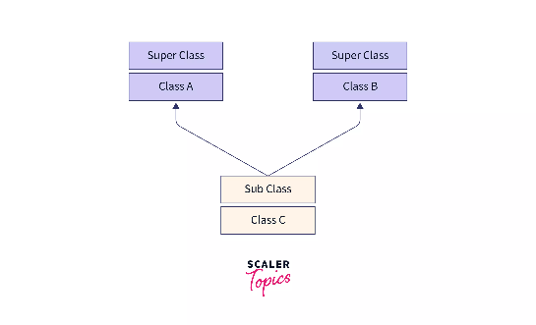

1. why do we need extends keyword?

By using extends keyword you know assess the data numbers are data from the parent class to our chilled class The static block is automatically executed during the loading of class

public class Multilevel {

public static void main(String[] args)

{

System.out.println("main method");

Orang m1 = new Orang();

m1.eating3();

m1.eating1();

m1.eating2();

}

}

class Fruit

{

void eating1()

{

System.out.println("eating a Fruit");

} }

class Apple extends Fruit

{

void eating2()

{

System.out.println("eating a apple");

}

}

class Orang extends Apple

{

void eating3()

{

System.out.println("eating a orang");

} }

1. How are u creating the object creation?

To create the object creation class name only

Class Kalyan{

Public static void main(String[] args)

{

Kalyan k1 = new Kalyan();//object creation with class name

}

}

1. why do we need the Abstraction?

To hiding the functionality, implementations with the respective role to the corresponding applications like SBI, LIC….

1. Why do we need of the constructor?

To insulation the instance variable

class employe

{

{

String name;

int id;

}

employe(String name,int id);

{

System.out.println(name+"/t"+id);

this.name=name;

this.id=id;

System.out.println("inside default connstructor in last");

}

public static void main(String[] args)

{

employe e1=new employe("gopi",123);

}

}

1. Do you have the implementation methods in the interface?

No implementation methods in interface

1. Do you have the implementation methods and method definition inside the abstract class?

Yes we can have.

class AbstarctClasss{

//implementation method

void abstarctMethodOne(){

System.out.println(“Implementation method inside abstract class”);

}// implementation method

//method definition

void abstarctMethodDefinaiotion(); // this is method definaition

}//class end

An abstract class can have an abstract method without body and it can have methods with implementation also.

1. What is the normal flow and abnormal flow?

Normal loss is defined as a type of loss that takes place in certain situations due to the nature of used processes and raw materials. Abnormal loss is defined as a type of loss that takes place due to some mischief or unexpected condition

Normal flow:-

statement 1;

statement 2;

statement 3;

statement 4;

statement 5;

statement 6;

statement 7;

statement 8;

statement 9;

statement 10; print the 10 statement is normal flow

abnormal flow:-

statement 1;

statement 2;

statement 3;

statement 4;

statement 5;//exception occurs

statement 6;

statement 7;

statement 8;

statement 9;

statement 10; print only 4 ,5 statement is exception to breck the program it is called abnormal flow

1. What is the role of in JVM?

. A Java virtual machine (JVM) is a virtual machine that enables a computer to run Java programs as well as programs written source code that are also compiled to Java bytecode.

1. Instance variable where it is showing /which location it well be store instance variable?

sInstance variable stored in the heap memory area.

it is declared inside the class out said the body of the method.

Class Kalyan{

Int a= 2;//instance variable

Int b =4;// instance variable

Public static void main(string[] args){

System.out.println(“hai”);

}

}

1. What about the heap memory?

heap is the area of memory used to store objects instantiated by applications running on the JVM

1. What will happen it use the new keyword?

The new keyword in Java is used to create an instance of a class, also known as an object. The new keyword in Java is used to allocate memory for the object on the heap, the memory space where objects are stored. The new keyword in Java calls the constructor of a class to initialize the object's state.

1. Which block are executed are static, instance?

Frist Static block is executed, and next instance block is executed.

class StaticBlock

{

static

{

for(long l=1;l<50;l++){

System.out.println("static block"+l);

}

}

public static void main(String[] args)

{

for(int i=2;i<10;i++){

System.out.println(i);

}

}

}

1. How it is executing static block?

Static block code executes only once during the class loading. The static blocks always execute first before the main () method in Java because the compiler stores them in memory at the time of class loading and before the object creation

1. How to execute static block?

The static block is automatically executed during the loading of class

1. How to call static block?

We can call static method but cannot call the static block

1. Who are calling static block?

JVM is called the static block

1. What time will be calling static block?

It runs once when the class is loaded into the memory.

1. What is the responsibility of class Loder sub system?

A class loader is an object that is responsible for loading classes. The class class Loader is an abstract class. Given the binary name of a class, a class loader should attempt to locate or generate data that constitutes a definition for the class.

1. Java platforms dependent is Independent?

Java is platform Independent

1. How r u saying java is platform Independent?

because it is compiled to a bytecode that can be run on any device that has a Java Virtual Machine (JVM)

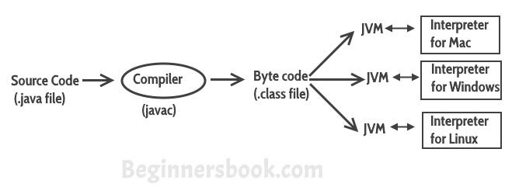

1. Where JAVAC in available in your system?

The javac.exe file is located in the bin folder of the JDK.

C:\Program Files\Java\jdk-20\bin

1. What is the role of the JDK?

The JDK is a development environment for building applications, applets, and components using the Java programming language. The JDK includes tools useful for developing and testing programs written in the Java programming language and running on the Java platform.

1. Where JDK in available in your system?

The JDK software is installed on your computer

C:\Program Files\Java

1. Why do we need the JDK?

JDK is java development kit. JDK is a software development environ meant which is used to develop java application and appley

1. why do we need object creation?

To call the instance vibrable, methods and constructor

To call the constructor

Class Kalyan(

{

String name;

int id;

}

Kalyan(String name,int id);

{

System.out.println(name+"/t"+id);

}

Public static void main(string[] args)

Kalyan k9 = new Kalyan();

}

}

1. How to call the instance methods?

to create object creation, then well be call in the object refrains name + method name

class InstanceMethod

{

public void display()

{

int n=60;

String x="hai";

System.out.println(n);

System.out.println(x);

}

public static void main(String[] args)

{

InstanceMethod obj = new InstanceMethod();

obj.display();

System.out.println("hai");

}

}

1. If are not creating the object creation, Can I call the methods are not?

Not calling method without object creation

1. If are not creating the object creation, Can I call the static methods are not?

Yes, u calling static methods

class StaticMethod

{

static int k=45;

static int m=50;

static void staticdisplay()

{

System.out.println(k);

System.out.println(m);

}

public static void main(String[] args)

{

StaticMethod obj = new StaticMethod();

obj.staticdisplay();

}

}

1. Ones u create the object creation what will be happen?

By using new operator, object memory will e created inside heap memory. At the time of object creation, if any instance variables are there then those will allocate memory inside object Memory. It will assign object memory address to the reference variable which is created first

1. why do we need this keyword?

This is a keyword it represents current class/object.it is used to inside the constructor.

employe(String name,int id);

{

System.out.println(name+"/t"+id);

this.name=name;

this.id=id;

System.out.println("inside default connstructor in last");

}

1. Where are using this keyword?

It is used to inside the constructor and methods

employe(String name,int id);

{

System.out.println(name+"/t"+id);

this.name=name;

this.id=id;

System.out.println("inside default connstructor in last");

}

1. If am creating A class B class and C class and C extends A, B what will be happen/That is what concept?

It is called multiple inheritance, multiple inheritance java not support

Example: -

class Bike

{

public void petrol()

{

System.out.println("bike");

}

}

class TwoViler

{

public void petrol()

{

System.out.println("Two viler");

}

}

class Hero extends Bike,TwoViler

{

}

public class Main

{

public static void main(String[] args)

{

Hero obj = new Hero(); // creating object of class hero

obj.execute(); // petrol() method is present in both class Bike and TwoViler

}

}

1. How to create the customize exception?

To create a custom exception, we have to extend the java. lang. Exception class. Note that we also have to provide a constructor that takes a String as the error message and called the parent class constructor

public class MyClass {

public void myMethod(int value) throws CustomException {

if (value < 0) {

throw new CustomException("Value cannot be negative");

}

}

}